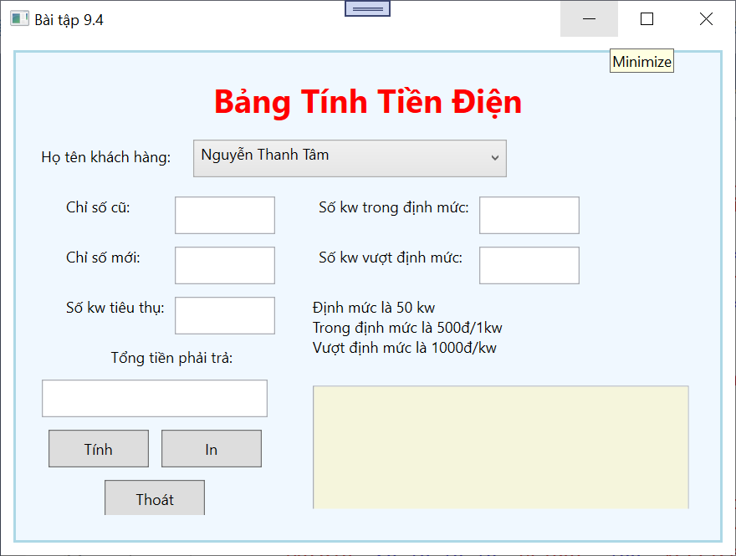

**CODE STYLE trong file App.xaml**

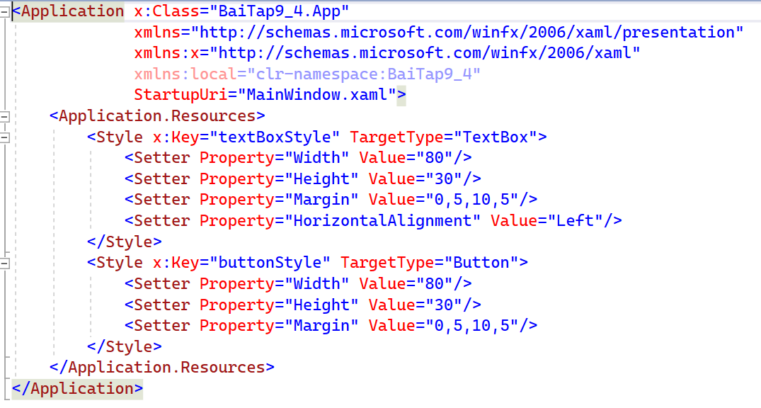

**CODE GIAO DIỆN**

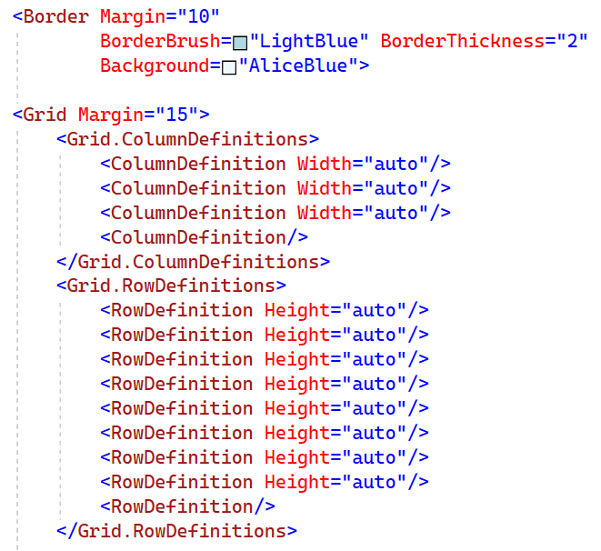

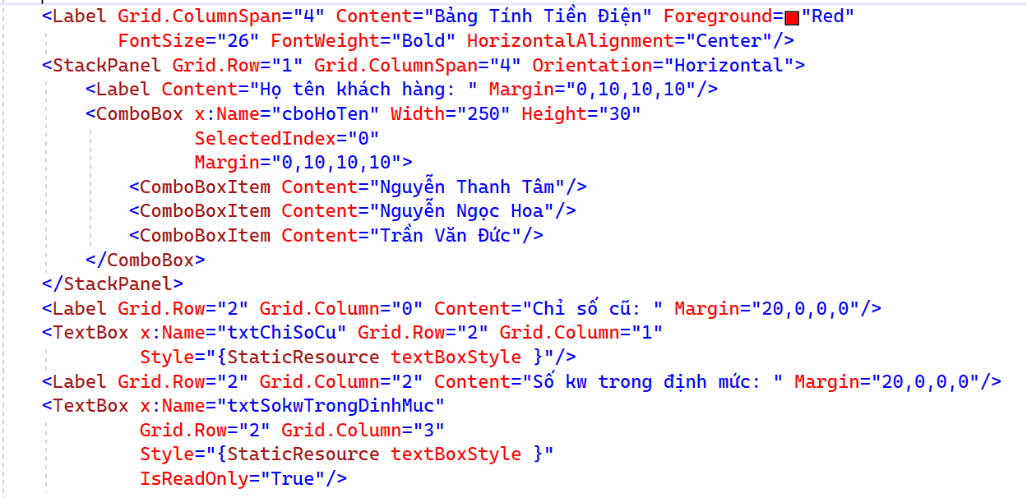

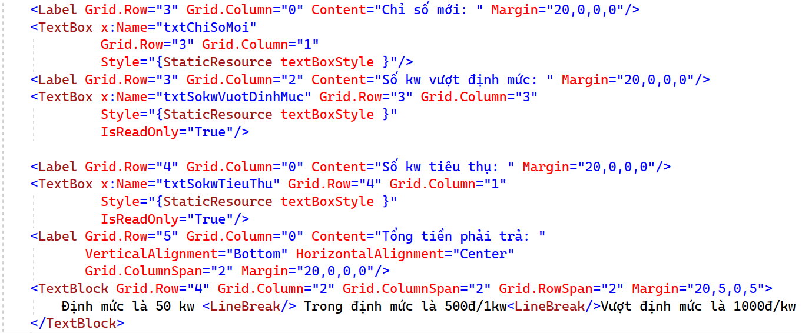

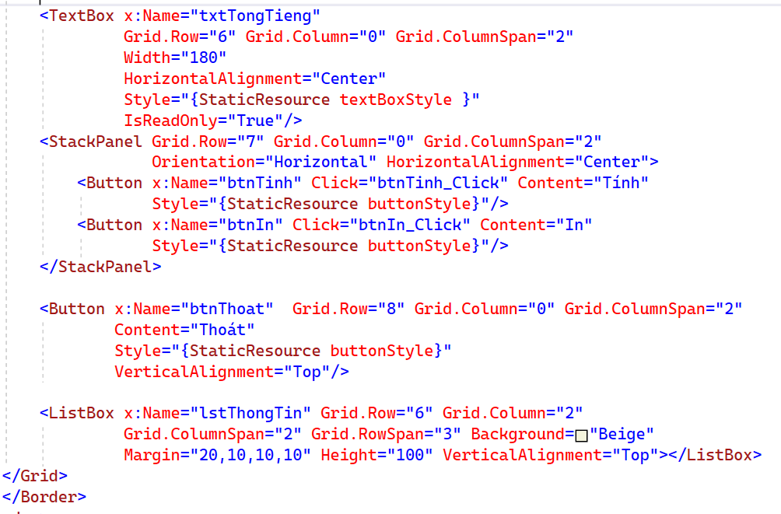

**CODE C#**

namespace BaiTap9_4

{

/// <summary>

/// Interaction logic for MainWindow.xaml

/// </summary>

public partial class MainWindow : Window

{

public MainWindow()

{

InitializeComponent();

}

double soKwTieuThu, tongTien;

private void btnTinh_Click(object sender, RoutedEventArgs e)

{

double chiSoCu, chiSoMoi, sokwTrongDinhMuc, sokwVuotDinhMuc = 0;

chiSoCu = double.Parse(txtChiSoCu.Text);

chiSoMoi = double.Parse(txtChiSoMoi.Text);

soKwTieuThu = chiSoMoi - chiSoCu;

if (soKwTieuThu <= 50)

{

sokwTrongDinhMuc = soKwTieuThu;

tongTien = soKwTieuThu * 500;

}

else

{

sokwTrongDinhMuc = 50;

sokwVuotDinhMuc = soKwTieuThu - 50;

tongTien = 25000 + sokwVuotDinhMuc * 1000;

}

txtSokwTieuThu.Text = soKwTieuThu.ToString();

txtTongTieng.Text = tongTien.ToString("N0");

txtSokwTrongDinhMuc.Text = sokwTrongDinhMuc.ToString();

txtSokwVuotDinhMuc.Text = sokwVuotDinhMuc.ToString();

}

private void btnIn_Click(object sender, RoutedEventArgs e)

{

lstThongTin.Items.Clear();

lstThongTin.Items.Add(cboHoTen.Text);

lstThongTin.Items.Add("Số kw tieu thu: " + soKwTieuThu);

lstThongTin.Items.Add("Tong tien: " + tongTien.ToString("N0"));

}

}

}